CASE Tools

CASE stands for Computer Aided Software Engineering which is software that supports one or more software engineering activities within a software development process, and is gradually becoming popular for the development of software as they are improving in the capabilities and functionality and are proving to be beneficial for the development of quality software.

Characteristics
A CASE tool must have the following characteristics in order to be used efficiently:
- A standard methodology: A CASE tool must support a standard software development methodology and standard modelling techniques. In the present scenario most of the CASE tools are moving towards UML.
- Flexibility: Flexibility in use of editors and other tools. The CASE tool must offer flexibility and the choice for the user of editors' development environments.
- Strong Integration: The CASE tools should be integrated to support all the stages. This implies that if a change is made at any stage, for example, in the model, it should get reflected in the code documentation and all related design and other documents, thus providing a cohesive environment for software development.
- Integration with testing software: The CASE tools must provide interfaces for automatic testing tools that take care of regression and other kinds of testing software under the changing requirements.
- Support for reverse engineering: A CASE tools must be able to generate complex models from already generated code.
- On-line help: The CASE tools provide an online tutorial.

Advantages and Disadvantages

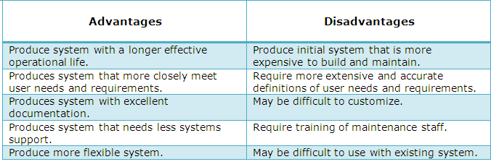

Classification
- Diagram tools
These tools are used to represent system components, data and control flow among various software components and system structure in a graphical form. For example, Flow Chart Maker tool for creating state-of-the-art flowcharts.
- Process Modeling Tools
Process modeling is method to create software process model, which is used to develop the software. Process modeling tools help the managers to choose a process model or modify it as per the requirement of software product. For example, EPF Composer
- Project Management Tools
These tools are used for project planning, cost and effort estimation, project scheduling and resource planning. For example, Creative Pro Office, Trac Project, Basecamp.
- Documentation Tools
Documentation in a software project starts prior to the software process, goes throughout all phases of SDLC and after the completion of the project. For example, Doxygen, DrExplain, Adobe RoboHelp for documentation.
- Analysis Tools
These tools help to gather requirements, automatically check for any inconsistency, inaccuracy in the diagrams, data redundancies or erroneous omissions. For example, Accept 360, Accompa, CaseComplete for requirement analysis, Visible Analyst for total analysis.
- Design Tools
These tools help software designers to design the block structure of the software, which may further be broken down in smaller modules using refinement techniques. For example, Adobe Illustration, Photoshop.
- Configuration Management Tools
Configuration Management tools deal with –
- Version and revision management
- Baseline configuration management
- Change control management
For example, Fossil, Git, Accu REV.
- Programming Tools
These tools consist of programming environments like IDE (Integrated Development Environment), in-built modules library and simulation tools. For example, Cscope to search code in C, Eclipse.
- Prototyping Tools
Software prototype is simulated version of the intended software product. Prototype provides initial look and feel of the product and simulates few aspect of actual product. For example, Serena prototype composer, Mockup Builder.

- Web Development Tools
These tools assist in designing web pages with all allied elements like forms, text, script, graphic and so on. For example, Fontello, Adobe Edge Inspect, Foundation 3, Brackets.
- Quality Assurance Tools
QA tools consist of configuration and change control tools and software testing tools. For example, SoapTest, AppsWatch, JMeter.
- Maintenance Tools
Software maintenance includes modifications in the software product after it is delivered. For example, Bugzilla for defect tracking, HP Quality Center.

